Step 1: Log into Infinite Campus

Step 2: Click Index

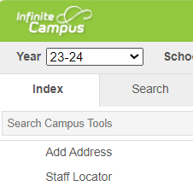

Step 3: Click on Ad Hoc Reporting

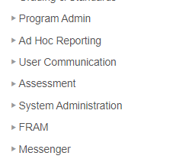

Step 4: Click Filter Designer

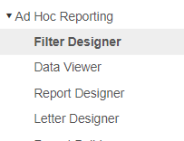

Step 5: Open Ad Hoc ES Secretary for elementary secretaries or Ad Hoc Registrars for high school and middle school registrars. Select student Directory Information/External Media.

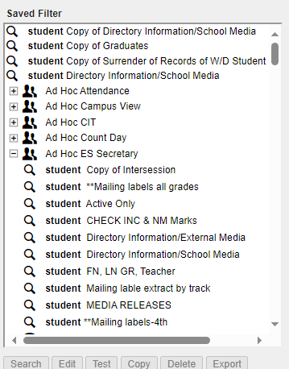

Step 3: Select Edit

Step 4: Next

Step 5: Select “N” for Feilds 8. customPerson.School/Media and 9. customPerson.RestrictDirectoryInfo.

Step 6: Select Save & Test. This will produce your list of students who selected “No” to directory information and School media during OLR.